### **SCARISBRICK ANNUAL PARISH MEETING**

All are welcome to attend, but only Electors of the Parish will have the right to raise and vote upon issues affecting the Parish.

The meeting will be held in St Mark’s Parish Hall, Southport Road, Scarisbrick on

**Tuesday 9th May 2023 at 7.00pm**

Under the Chairmanship of Councillor John Herbert

(Chairman of Scarisbrick Parish Council).

AGENDA

1. Welcome.
2. Apologies for absence.
3. Confirmation of the minutes of the meeting held on Monday 23rd May 2022.
4. Matters arising from the minutes.
5. Chairman’s Annual Report.
6. Public participation – opportunity for the electorate of Scarisbrick to raise issues affecting the Parish.
7. Chairman’s closing remarks.

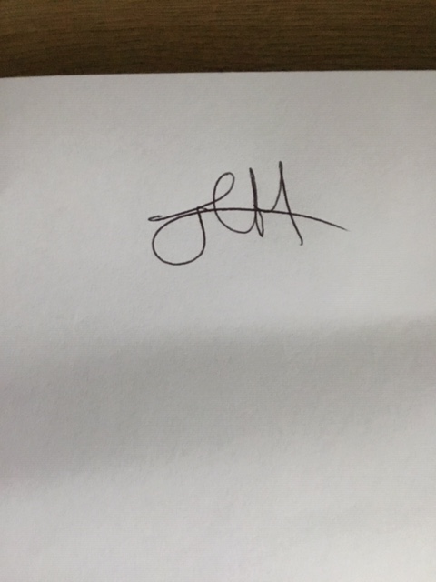



Chairman of Scarisbrick Parish Council